Henry Wiltse
- Memorial
- Photos
- Flowers
- Edit
- Share
Learn about sponsoring this memorial...
Birth: | Feb. 7, 1799
Death: | 1881
Family links:
Children:
Phebe Wiltse Wiltse (1828 - 1887)*
*Calculated relationship
Burial:
Beckwith Cemetery
Nilesville
Floyd County
Iowa, USA
Edit Virtual Cemetery info [?]
Created by: Kathy Gerkins
Record added: Jul 21, 2003
Find A Grave Memorial# 7699415

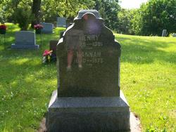
Added by: Kathy Gerkins
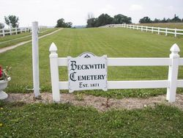
Cemetery Photo

